Activity Ideas for Home: Provided by EBS Occupational Therapy
*These links are general ideas for activities to complete at home and are not intended to replace or represent direct therapy services*

General Hand Exercises
https://www.ot-mom-learning-activities.com/hand-exercises-for-kids.html#GeneralHandExercises

Cut and paste activities
https://www.yourtherapysource.com/files/Cut_and_Paste_Puzzles.pdf

https://d3eizkexujvlb4.cloudfront.net/2017/05/30200315/Color-Cut-Glue-Scissor-Practice-for-Spring-Time-from-Your-Therapy-Source1.pdf

Play Dough Exercises
https://www.ot-mom-learning-activities.com/hand-exercises-for-kids.html#PlaydoughHandExercises

Tactile Activities
https://www.ot-mom-learning-activities.com/tactile-perception-activities.html#HouseholdObjectTactileGame

Find the hidden objects in the pictures
http://eyecanlearn.com/perception/figure-ground/

Try to remember the pictures in order after they disappear
http://eyecanlearn.com/perception/sequential-memory/

Say the direction of the arrow: up, down, left, right.
http://eyecanlearn.com/perception/spatial/arrows/

Fine motor activity ideas for at home video
https://www.youtube.com/watch?v=Tzqif7Cq5UI

Movement Activities
Videos Retrieved from: https://family.gonoodle.com/

Stretching, focusing, calming
https://family.gonoodle.com/channels/empower-tools

Mindfulness Activities
https://family.gonoodle.com/channels/flow
How-to Activities
https://family.gonoodle.com/channels/how-to
Guided Dances
https://family.gonoodle.com/channels/ntv-noodle-television

Household chores for extra movement

- Set the table
- Push in chairs after meal times
- Help carry laundry from one room to another or help load/unload laundry from washer/dryer
- Help carry groceries into the house or put away groceries
- Help with sweeping the floor/pushing a sweeper/vacuum
- Dusting
- Wipe down table after meal
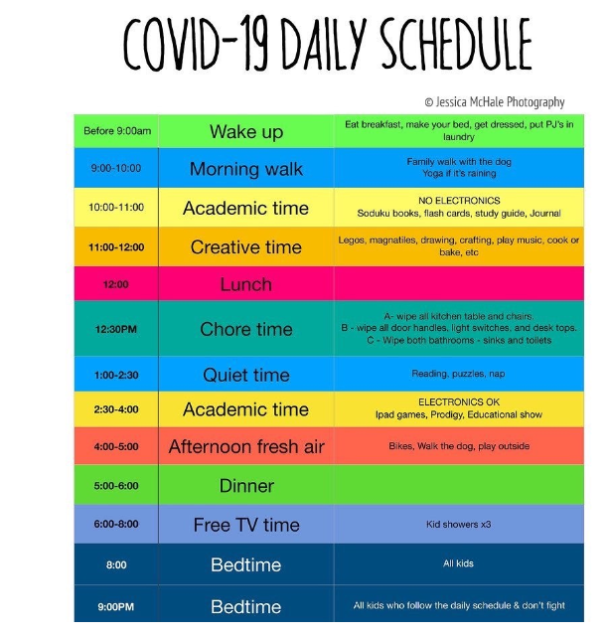
Breathing
Calm App Breathing Bubble
https://www.youtube.com/watch?v=5DqTuWve9t8

Daily Schedule Idea

